***CYCLE MODULE***

Tables:

Cycle table is needed to encapsulate activities that repeated until the main purpose is served. It is also

***Example***,:

Harvet is an ongoing activity that is broken down into cycles. During each cycle pods form entire plantation get picked. The prosess starts at plot 1 and ends when all plots are visited.

Harvest cycle may take two weeks or more depending on the season.

Each day of the cycle **same activity** being performed. Human, material and machine resourses are being recorded under daily **activity.**

**New Table:**

|  |  |  |  |
| --- | --- | --- | --- |
| CYCLE | |  |  |
| PK | Cycle_ID |  |  |
| PK | IDcrop | FK |  |
|  | IDactivityName | FK |  |
|  | HR required |  | Boolean |
|  | Machine required |  | Boolean |
|  | Service required |  | Boolean |
|  | Materials required |  | Boolean |
|  | Cycle number |  | smallint |
|  | Initial Date |  | Date |
|  | Final Date |  | Date |
|  | Cost of HR Budget |  | real |
|  | Cost of HR Actual |  | real |
|  | Cost of Machines Eq. Budget |  | real |
|  | Cost of Machines Eq. Actual |  | real |
|  | Cost of Services Budget |  | real |
|  | Cost of Service Actual |  | real |
|  | Cost of Materials Budget |  | real |
|  | Cost of Materials Actual |  | real |

**Altered Table**: **Activity.**

Add Cycle_Id as new field to Activity table.

***USER INTERFACE***

In order to register new new cycle user needs:

* Register New Cycle Form
* CYCLE MANAGEMENT FORM

***Register new CYCLE:***

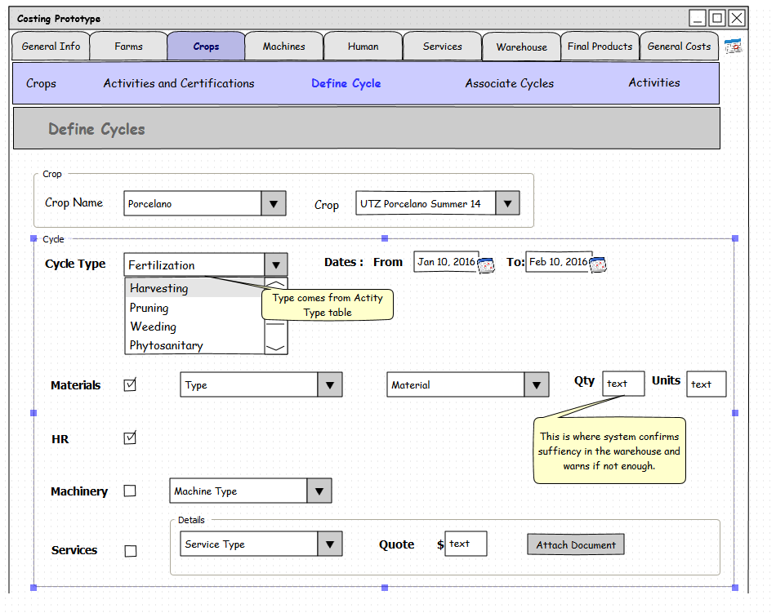

* From ***CROP*** Tab user selects ***DEFINE CYCLE*** 🡪 ***Register new Cycle*** item.

1. Form opens up with “Crop” from which user make a selection of crop Name (Type) and Crop.

2. System opens “Cycle” form

3. User Selects

1. **Cycle Type (selection** is driven by Activity Name table that contains all possible names). Only activities that have same Acvitity Name can be added to the cycle (or created under the cycle) – Required Field
2. **Dates –** Required Field
3. **Check Boxes –** Materials, HR, Machinery, Services - optional

* If materials are selected System dynamically activates Type, Materials drop downs and Qty and Units fields.
* If Machinery is selected “Machine Type” drop down gets activated
* If Services are selected “Service Type” that has list of available types and Quote field are activated. “Attach” button should allow user to upload documentation( like PDF, Doc., etc)

User Clicks “SAVE” button to save newly created cycle.

***Manage CYCLES:***

From Manage Cycles Form user can edit Cycles, Budget costs and see all existing cycles and filter them by type.

* From CROP Tab user selects ***DEFINE CYCLE*** 🡪 ***Manage Cycles*** menu item

1. Form opens up with “Crop” from which user make a selection of crop Name (Type) and Crop.

2. Once user made a crop selection, in the form below appears list of all the cycles related to the Crop (that have Crop. Crop_ID = Cycle.Crop_ID)

3. User Selects radio button on the left to see the Budget and Actual costs for each category that have check box. Budget cost is editable field. Actual cost is calculated filed.

For Example: Weeding Cycle has all 4 (materials, machinery, HR, and Services) check boxes marked. Therefore 4 line items with related Budget and Actual Cost information will appear below.

4. User clicks ”SAVE” button to save changes.

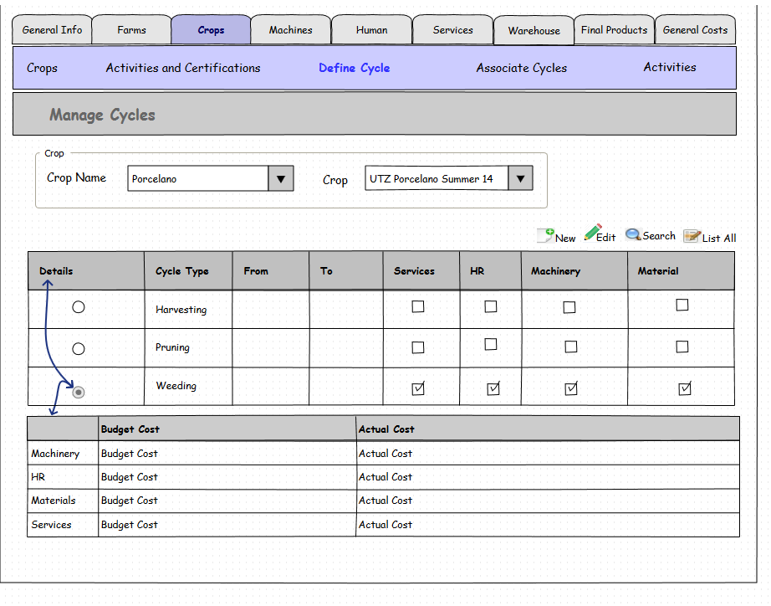

**Budget Cost**: Where you edit this value?

As calculate the **Actual Cost**?